Complete the following tasks that pertain to Chapter 8 of the textbook.

1. List just the description in the ITEM table for the seller ID “a100”;

Attach SQL statement here.

Select DESCRIPTION from item where SELLERID= 'a100';

Attach screen shots of your script output here

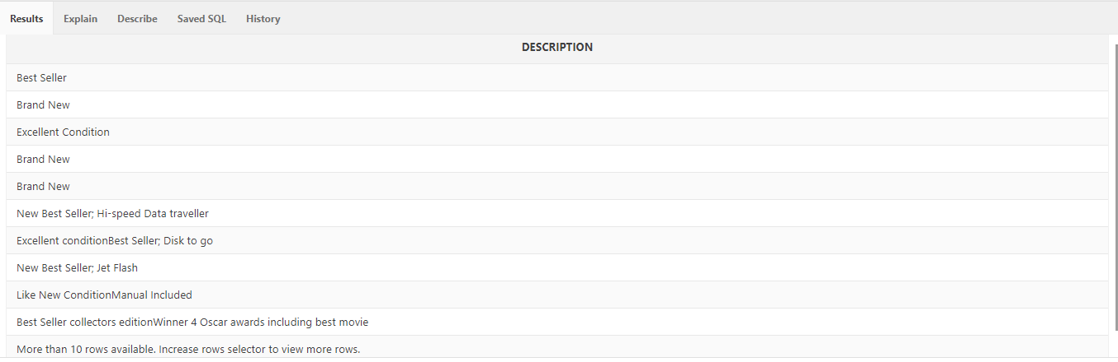

1. List the titles and starting bid from the ITEM table where the starting bid is over $100.00 listed in descending order, based on the starting bid.

Attach SQL statement here.

select TITLE,STARTINGBID from ITEM where STARTINGBID > 100.00 order by STARTINGBID desc ;

Attach screen shots of your script output here

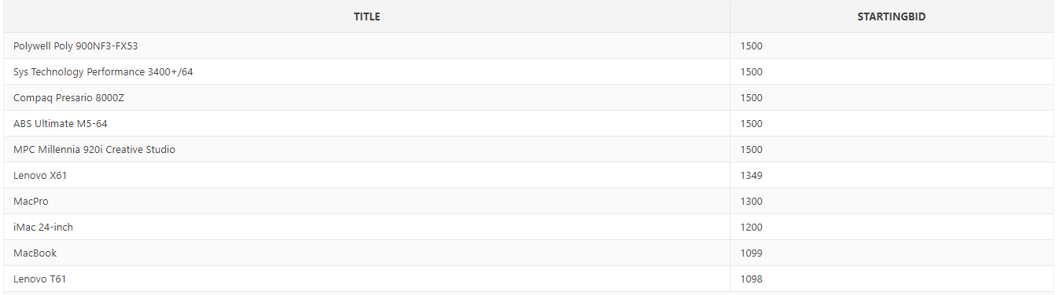

1. List the titles and starting bid from the ITEM table where the CID is either 11 or 31 and the starting bid is over $10.00 but under $100.

Attach SQL statement here.

select TITLE, STARTINGBID from Item where CID in (11,31) and (STARTINGBID > 10.00 and STARTINGBID < 100);

Attach screen shots of your script output here

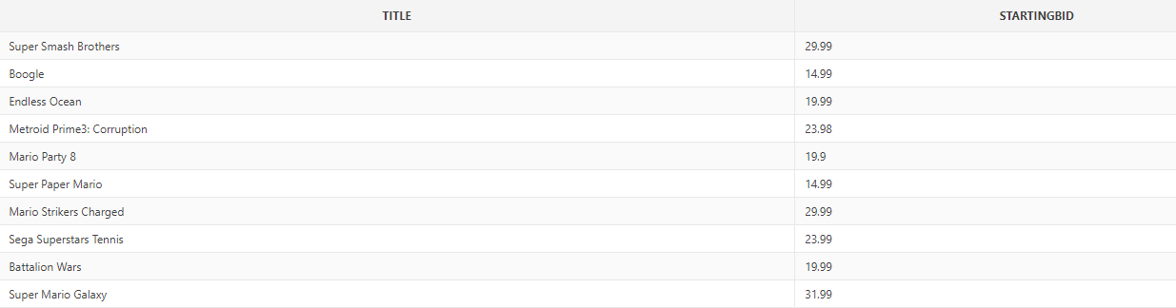

1. List all the titles and winnerid from the ITEM table where someone has won a bid.

Attach SQL statement here.

select TITLE, WINNERID from Item where WINNERID is not null ;

Attach screen shots of your script output here

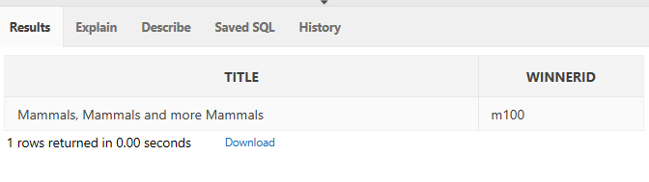

1. List all the titles from the ITEM table that start with “The”.

Attach SQL statement here.

select TITLE from Item where title like 'The%' ;

Attach screen shots of your script output here

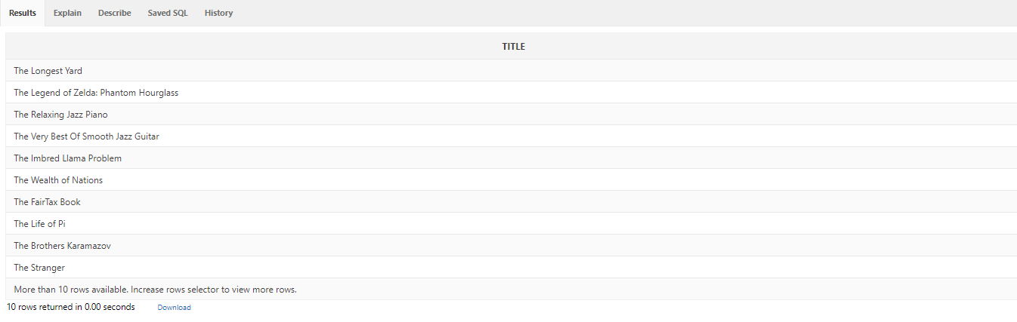

1. List the titles, opening date and closing date from the ITEM table between January 1, 2008 and February 27, 2008.

Attach SQL statement here.

select TITLE, OPENDATETIME ,CLOSEDATETIME from Item where OPENDATETIME >='1-JAN-08' and CLOSEDATETIME <= '27-FEB-08';

Attach screen shots of your script output here

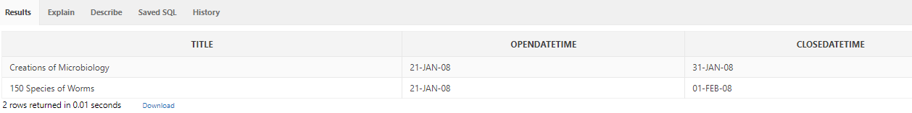

7, 8 List the first name, last name, and the renew date from the CUSTOME_X table who’s renew were in 2012. Use 2 DIFFERENT methods:

Attach SQL statement here.

select CUS_FNAME,CUS_LNAME,CUS_RENEW_DATE from CUSTOMER_X where CUS_RENEW_DATE between ’01-JAN-12' and ’31-DEC-12' ;

Attach SQL statement here.

select CUS_FNAME,CUS_LNAME,CUS_RENEW_DATE from CUSTOMER_X where CUS_RENEW_DATE >= ’01-JAN-12' and CUS_RENEW_DATE <= ’31-DEC-12' ;

Attach screen shots of your script output here

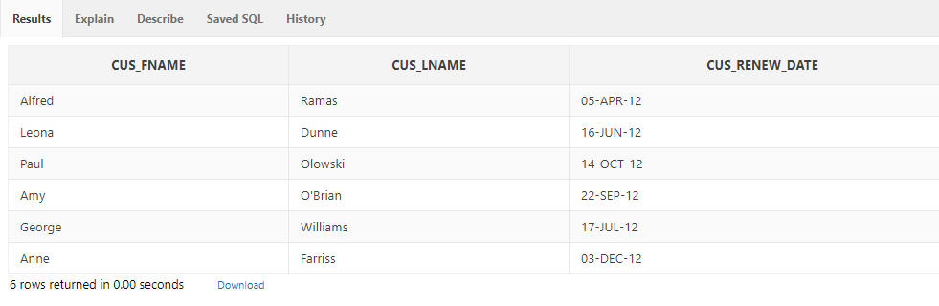

1. List all the titles and the “Highest Winning Bid” in the ITEM table where the “Highest Winning Bid” is less than $10.00 if there was one bid a day placed on each item.

Attach SQL statement here.

Select TITLE, ((( CLOSEDATETIME - OPENDATETIME) * BIDINCREMENT) + STARTINGBID) as "highest bid" from item where (((CLOSEDATETIME - OPENDATETIME) * BIDINCREMENT)+ STARTINGBID) < 10 ;

Attach screen shots of your script output here

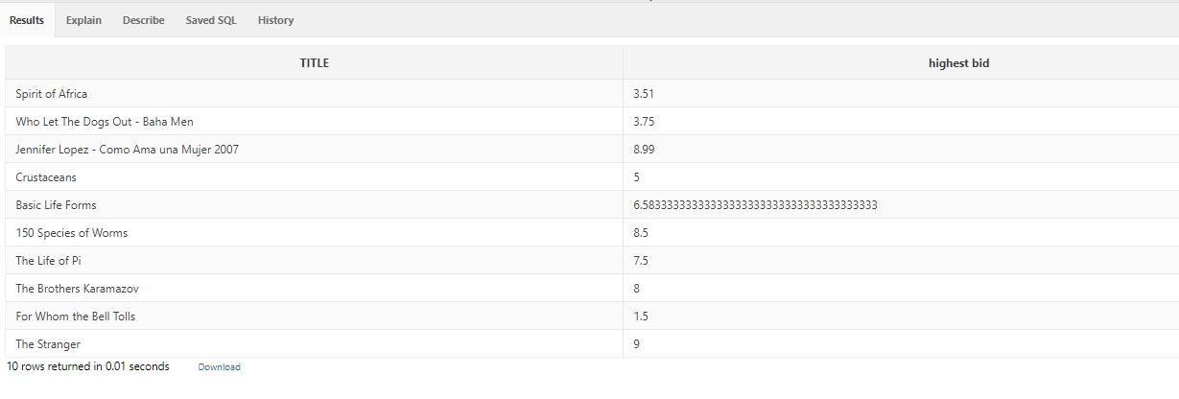

1. List the name from the CATEGORY table of all entries in the CATEGORY that have a word with the letter ”S” in them.

Attach SQL statement here.

select CNAME from CATEGORY where CNAME like '%S%';

Attach screen shots of your script output here

